## Document Information

**Document Title:** Using FTXFixer.exe

**Document file name:** Using FTXFixer.docx

**Revision Number:** 1.3

**Document Author:** Amresh Kumar

**Issue Date:** 05/08/2017

**Update Date:** 01/10/2018

**Status:** Ready for QA

## 

## Revision History

|  |  |  |  |
| --- | --- | --- | --- |
| Version | **Date** | **Author** | **Description** |
| 1.0 | 06/15/2017 | Amresh Kumar | Initial draft |
| 1.1 | 06/19/2017 | Amresh Kumar | Added application message detailing. Unit testing completed. |
| 1.2 | 07/05/2017 | Amresh Kumar | Added reload settings and troubleshooting section. |
| 1.3 | 01/10/2018 | Amresh Kumar | Updated per changes in FTXFixer version 1.4 |

**Notes:** Demo pictures shown in this manual may not exactly match with FTXFixer UI. Internals of FTXFixer are updated more frequently than documentation and demo pictures may not be in sync.

Contents

1. REQUIREMENTS
   1. Supported Operating Systems
   2. Minimum Hardware Requirements
   3. Software Requirements
2. INTRODUCTION
   1. Minimum settings requirement to run
   2. Post processing validation (to be done manually)
3. SETTING INPUT AND OUTPUT PATH
   1. Setting input location
   2. Setting output location
   3. Enabling footer option
   4. Opting to clean existing output
4. ADDING NEW PATTERN AND ENABLING LOGGING
   1. Adding new pattern
   2. Removing existing pattern
   3. Undo last pattern removal
   4. Removing all patterns
5. LOG SETTINGS
   1. Setting log location
   2. Article level logging
   3. Input history logging
   4. Output history logging
6. MENU OPTIONS
   1. Logs and Pattern Settings
   2. Open Settings INI
   3. Reload Settings INI
   4. Open Input Location
   5. Open Output Location
   6. Open Log Location
   7. About FTXFixer
7. APPLICATION RUNTIME MESSAGES
   1. Critical messages
   2. Error messages
   3. Warning messages
   4. Informative messages
   5. Operational messages
8. TROUBLESHOOTING
   1. Application fails to launch
   2. Application launches with default settings
   3. Application launches with similar settings (aka not comitting changes)
   4. Application fails to log articles
   5. Application fails to log input files
   6. Application fails to log output files
   7. Application fails to read input files
   8. Application fails to write output files
9. APPLICATION UI

**REQUIREMENTS**

* **Supported Operating Systems:**
  + Windows 7 SP1 (x86 and x64)
  + Windows 8.1 (x86 and x64)
  + Windows 10 (x86 and x64)
  + Windows Server 2008 R2 SP1 (x64)
  + Windows Server 2012 (x64)
  + Windows Server 2012 R2 (x64)
* **Minimum Hardware Requirements:**
  + 1 GHz or faster processor
  + 512 MB of RAM
  + 500 MB of available hard disk space (x86 or x64) (for .NET installation)
* **Software Requirements:**
  + .NET 4.5.2 ([Download Here](https://download.microsoft.com/download/4/3/B/43B61315-B2CE-4F5B-9E32-34CCA07B2F0E/NDP452-KB2901951-x86-x64-DevPack.exe))
  + ExpoSDF.exe (Gauss DB Exporter)
  + Gauss Database

**INTRODUCTION**

FTXFixer.exe processes FTX data extracted by ExpoSDF application. If INI file not found during launch, application creates one with values available in current state. Settings INI file can be updated manually or by setting values in application. FTXFixer.exe is a UI application written in WPF and designed to perform followings:

* Saves and loads setting from INI file (INI location is set to default as EXE, insure write permission).
* Processes FTX input files (F*.M*) and generates replacement FTX (FM*.M*) data files against each input file. Every articles header are fixed to prepare them for replacement data. @@@@ are added regardless of article data starting with @@@ or @@@@@@@.
* Transforms old style (F?YYMMDD.M??) full text output file name to new style (FMYYYYMD.M??, only replacement full text file) full text file name. Default compatibility with new style full text file name pattern.
* Fixes articles checksum if found wrong. ExpoSDF extracts data with incorrect checksum which is taken care during processing.
* Removes specified patterns. Some of standard patterns such as [?? OMITTED] or [?? OMITTED.] are handled by default.
* Doesn’t let article go into output with empty body.
* Adds footer data (based on selection) during processing if article qualifies for footer and footer option enabled.
* Updates input and output history file if history enabled.
* Writes logs against each article with details on number of patterns removed and footer status.
* Opens usage document (file named “Using FTXFixer.pdf”) after pressing F1 key if document available at EXE location and starts processing after pressing F5 key.

**Minimum settings requirement to run:**

* Set input location
* Set output location
* Insure full text file (F*.M*) availability at input location
* Insure write permission at output location

**Post processing validation (to be done manually):**

* Application derives output file name from input file as F?GSMMDD.M??/F?YYMMDD.M?? (ExpoSDF output file name) to FMYYYYMD.M?? (YYYYMD is four digit year, month and date). This is done to prepare full text file ready for replacement. Insure final replacement file name is not yet processed into Gauss. In case if final replacement file already available in Gauss processed list (\\newton\volume_1\history\taken\ftxmain.red), manually rename final output or remove the entry from processed list before processing final output file into Gauss.

**SETTING INPUT AND OUTPUT PATH**

**Setting input location:** Click on SET button as highlighted below and select input path from folder browser dialog.

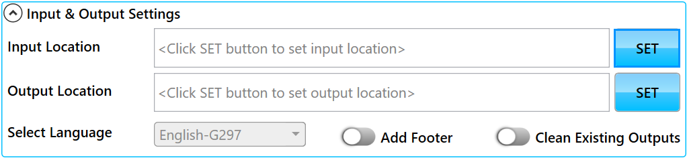

Selected input path will be updated in setting INI file as value of input key under “Locations” section and remain available unless changed or setting INI file deleted.

**Setting output location:** Click on SET button as highlighted below and select output path from folder browser dialog.

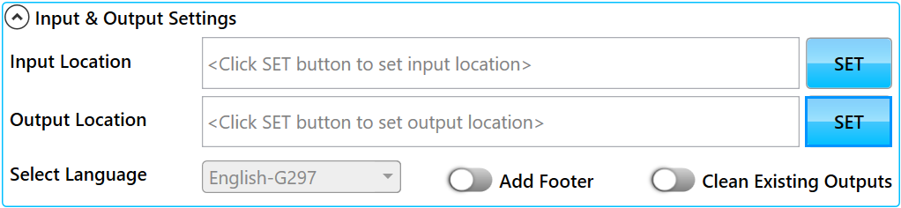

Selected output path will be updated in setting INI file as value of output key under “Locations” section and remain available unless changed or setting INI file deleted.

**Enabling footer option:** Check “Add Footer” option and select footer language as highlighted below. Enabling footer option will add footer at end of article data if article qualifies for footer. Article qualifies for footer if article contains at least one pattern as [?? OMITTED]. Footer is not added into article data and footer language selection remain disabled if “Add Footer” option is not enabled. Footer selection is not updated in INI file and needs to be set explicitly before processing.

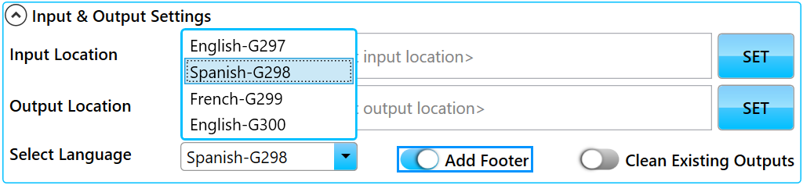

Footer language is not added to article unless “Add Footer” option is enabled (GAUSS-296). If “Add Footer” option is enabled, selected footer languages will add footer line at end of article data as explained below.

* **English-G297** - “----------” followed by line “Please Note: Illustration(s) are not available due to copyright restrictions.” (For JIRA ticket GAUSS-297)
* **Spanish-G298** - “----------” followed by line “Aviso: Ilustración(es) no disponible(s) por restricción de derechos de autor.” (For JIRA ticket GAUSS-298)
* **French-G299** - “----------” followeedby line “Veuillez noter que l’iIllustration(s) est non disponible(s) en raison des restrictions de droits d'auteur.” (For JIRA ticket GAUSS-299)
* **English-G300** - “----------” followed by line “Please note: Some tables or figures were omitted from this article.” (For JIRA ticket GAUSS-300)

**Opting to clean existing output:** In case if “Clean Existing Outputs” enabled, existing outputs at output location will be deleted before writing new output. If this option and output history logging option both disabled, existing output file will get overwritten if there a name conflict. This option is saved into settings INI file as value to key “CleanOutput” under “Misc” section. Enable option as highlighted below.

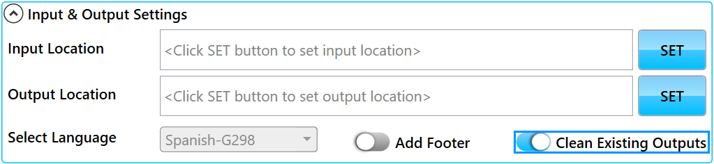

**ADDING NEW PATTERN AND ENABLING LOGGING**

**Adding new pattern:** Click on “Add Pattern & Log Settings” button as highlighted below.

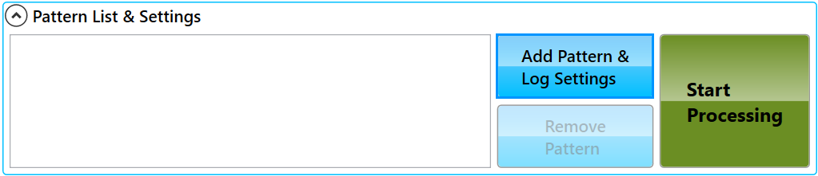

This will bring “Logs and pattern settings” window. Enter new pattern into “Add Pattern” box and press enter or click “ADD” button as highlighted below. Pattern will not be added unless a new (non existing) and valid pattern is entered. Change pattern value in box and press enter or click “ADD” button to enter next pattern. Press ESC key or click “CLOSE” button to close “Logs and pattern settings” window. Non standard pattern (not starting and ending with []) are displayed in indigo color while standard pattern is displayed in black color.

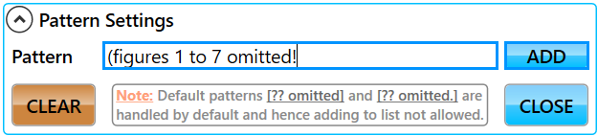

**Note:** Typing new pattern is assisted with auto completion from existing list. To enter similar pattern, start typing pattern name, then auto complete by pressing right key (→) or delete key followed by futher modifications.

**Removing existing pattern:** Click on “Remove Pattern” button as highlighted below.

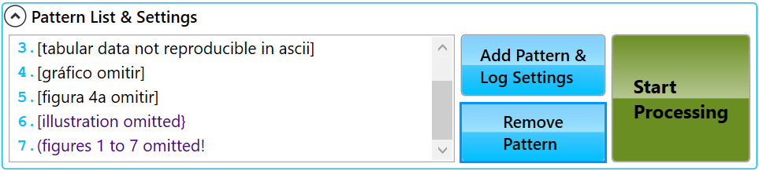

Click “Remove Pattern” will remove selected pattern. Last pattern will be removed if pattern not selected before attempting removal.

**Undo last pattern removal:** Once pattern/s removed, Undo button will appear at right bottom corner of pattern list. Click on undo button to add last removed pattern back to list. Undo button doesn’t disappear unless all removed pattern are undone. Cick on “Undo” button as highlighted below.

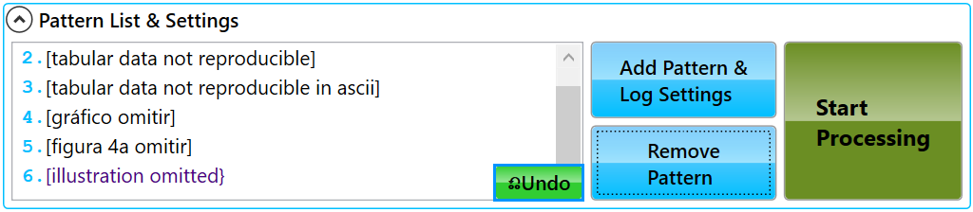

**Removing all patterns:** Click on “Add Pattern & Log Settings” button as highlighted below.

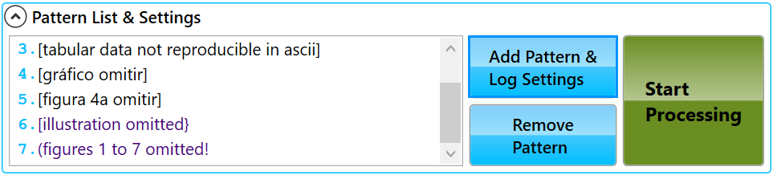

This will bring “Logs and pattern settings” window. As highlighted below, clicking on “CLEAR” button will bring a message box for confirmation. Confirming yes (by clicking “Yes” button in message box) will clear all patterns from pattern list.

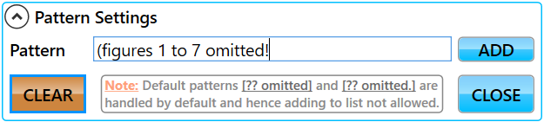

**LOG SETTINGS**

**Setting log location:** Click on SET button as highlighted below and select log path from folder browser dialog.

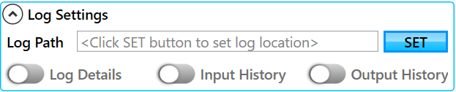

Selected log path will be updated in setting INI file as value of “Log” key under “Locations” section and remain available unless changed or setting INI file deleted. None of logging options can be enabled unless log location set in advance.

**Article level logging:** Enable “Log Details” as highlighted below to allow application article level logging.

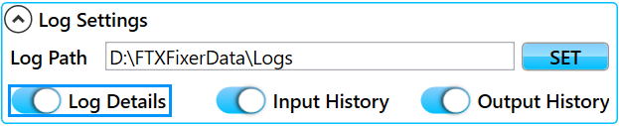

This option is updated in setting INI file as value of “Logging” key under “Misc” section and remain disabled unless log location set. Article level logging is written in FTXFIXER_DDMMYYYY.ANLOG file at log location. Next processing logging is appended on same day while a new log file is created if processing day differs. Logging data look like as illustrated below. NA against footer is logged when article body is empty.

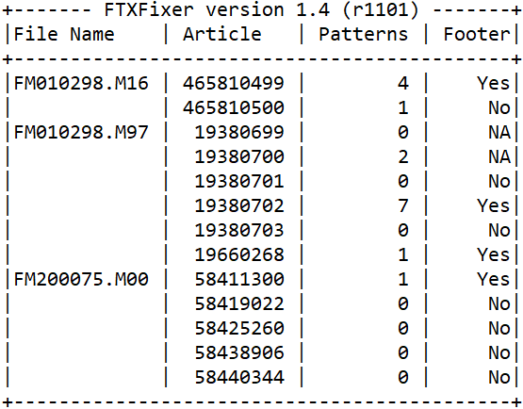

**Input history logging:** Enable “Input History” as highlighted below.

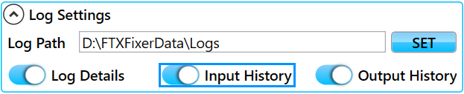

This option is updated in setting INI file as value of “InputHistory” key under “Misc” section and remain disabled unless log location set. If enabled, input history containing processed input file names (without location) will not be allowed to be processed else logged. Input history can be found as FTXINPUT.HST under log location and always appended with new entries if enabled.

**Output history logging:** Enable “Output History” as highlighted below.

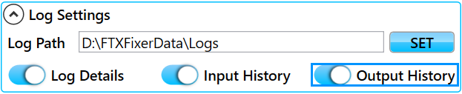

This option is updated in setting INI file as value of “OutputHistory” key under “Misc” section and remain disabled unless log location set. If enabled, output history containing processed output file names (without location) will not be allowed to be written else logged. Output history can be found as FTXOUTPUT.HST under log location and always appended with new entries if enabled.

**MENU OPTIONS**

Application has its own menu options under title border. Click upper left corner menu button or right click at any static area to bring menu and accession application menu items. Application menus are as explained below. Click on highlighted menu button as illustrated below.



**Logs and Pattern Settings:** Clicking this menu (shortcut key F2) item brings “Logs and pattern settings” window. See illustration below.

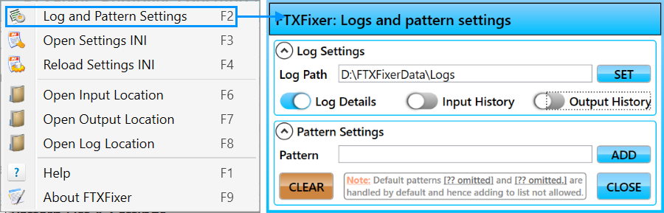

**Open Settings INI:** Clicking this menu (shortcut key F3) item opens setting INI file for easy access to edit manually. See illustration below.

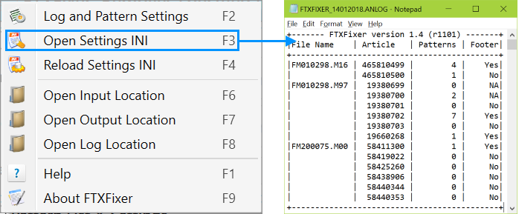

**Reload Settings INI:** Clicking this menu (shortcut key F4) item reloads settings from setting INI file. Making changes in application settings during run time doesn’t loose while reloading setting INI file as changes in settings are committed on the fly. See illustration below.

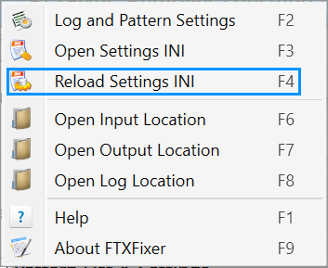

**Open Input Location:** Clicking this menu (shortcut key F6) item opens input location for easy access of input files. See illustration below.

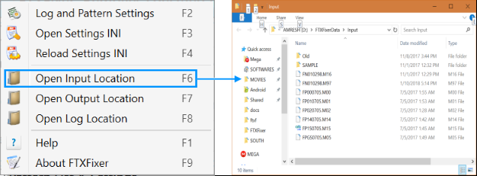

**Open Output Location:** Clicking this menu (shortcut key F7) item opens output location for easy access of output files. See illustration below.

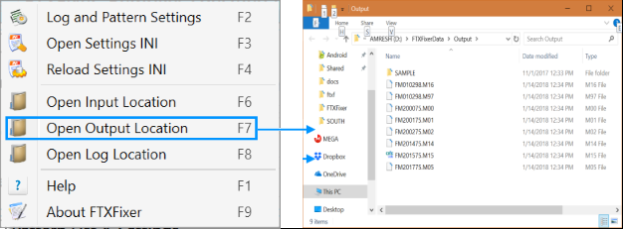

**Open Log Location:** Clicking this menu (shortcut key F8) item opens log location for easy access of input history, output history and article level log files. See illustration below.

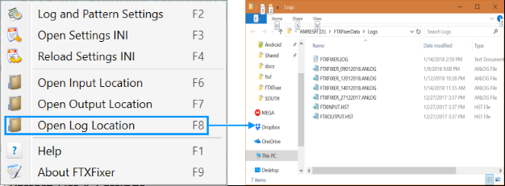

**About FTXFixer:** Clicking this menu (shortcut key F9) item opens application about box with version information. Application major and minor version is set manually but build version increases dynamically against every build. See illustration below.

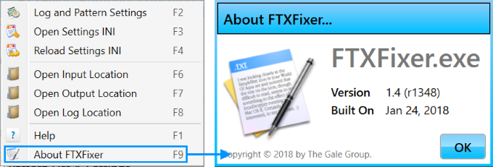

**APPLICATION RUNTIME MESSAGES**

Run time messages appears at status bar (bottom of application) as illustrated below and may appear in mutliple colors. These runtime message are also written into log file FTXFIXER.LOG. FTXFIXER.LOG is written at log location if log location is set else written at exe location. Each color maps to different message category.



Message at status bar may appear in four colors. Types of messages are as explained below.

**Critical messages:** A error message box appears with error message. These type of error messages appear when unrecoverable exception encountered. Some of examples are as followed:

* "Can't write article level log, check log location permission." - Displayed when log location doesn’t have write permission to write article level log.
* "Can't log input history, check log location permission." - Displayed when log location doesn’t have write permission to write input history.
* "Can't log output history, check log location permission." - Displayed when log location doesn’t have write permission to write output history.
* "Failed to write article level logging, check file permission." - Displayed when article level log file is set to read only.
* "Failed to update input history file, check file permission." - Displayed when input history file is set to read only.
* "Failed to update output history file, check file permission." - Displayed when output history file is set to read only.

**Error messages:** Status message appears in red color. These type of error messages appear when results are not as expected. Some of examples are as followed:

* “Error! Failed to read FN201747.M99” - Displayed when can’t access file FN201747.M99 for reading.
* “Error! Failed to write FM20162R.M17” - Displayed when can’t write to file FM20162R.M17.
* "Error! Input and output location isn't set yet, run aborted." - Displayed when either input, output or both locations are not set.
* "Error! Couldn't find any full text file, run aborted." - Displayed when input location doesn’t have any input file (F*.M*).

**Warning messages:** Status message appears in dark yellow color. Needs to be addressed when required or may result undesired result. May appear with message box. Some of examples are as followed:

* “Warning! 4 successfully processed, 3 failed to process. Check input history or permission." - Translates as, 4 files read but 3 failed due to already available in input history or not having read permission.
* “Warning! 3 successfully written, 5 failed to write. Check output history or permission." - Translates as, 3 files written but 5 failed due to already available in output history or not having write permission.
* "Warning! Input and output paths are same." - Displayed when user set same input and output location.
* “Warning! Process aborted by user." - Displayed when user aborts process while in progress.

**Informative messages:** Status message appears in black color. These messages appear against regular actions taken by user (such as setting input or output path) or if a regular information to be displayed by application (such as number of patterns loaded from setting INI file). Some of examples are as followed:

* “Pattern "[table omitted!" added successfully." - Displayed when users enters a valid pattern “[table omitted!”.
* “Settings successfully loaded with 7 patterns.” - Translates to, 7 patterns loaded from setting INI file (default patterns [?? omitted] or [?? omitted.] are skipped as they handled by default).

**Operational messages:** Status message appears in blue color. This occurs while application displays message during processing in progress. Some of examples are as followed:

* "Writing FM20162R.M17..." - Displayed when file FM20162R.M17 currently being written during processing.

**TROUBLESHOOTING**

1. **Application fails to launch:** Make sure .NET 4.5.2 (as referred in requirement) is installed in system.
2. **Application launches with default settings:** Make sure to have write permission at EXE location.
3. **Application launches with similar settings (aka not committing changes):** Make sure settings INI file is not set to read-only.
4. **Application fails to log articles:** Make sure log path is set in “Logs and pattern settings” window, “Log Details” option is enabled, log location has write permission and log file is not set to read-only.
5. **Application fails to log input files:** Make sure log path is set in “Logs and pattern settings” window, “Input History” option is enabled, log location has write permission and input history file is not set to read-only.
6. **Application fails to log output files:** Make sure log path is set in “Logs and pattern settings” window, “Output History” option is enabled, log location has write permission and output history file is not set to read-only.
7. **Application fails to read input files:** Make sure input location has read permission.
8. **Application fails to write output files:** Make sure output location has write permission.
9. **Application fails to remove omitted pattern with irregular braces:** In case if pattern appears as [[table omitted] or [table omitted.]], final output will be left with entries [ or ]. This happens because standard pattern removal are taken place strictly (I.e. only [?? omitted] and [?? omitted.] are removed. In order to address this issue, add omit pattern with irregular braces into pattern list. Pattern list are processed first before default omitted patterns are replaced and hence by the time omitted pattern replacement begins, omitted pattern with irregular braces will be addressed as they are available into pattern list.

**Note:** Regular omitted patterns [?? omitted] or [?? omitted.] are not allowed in pattern list but omitted patterns with irregular braces are allowed into list.

1. **Application fails to remove omitted pattern if omitted pattern added without braces:** For example - if a pattern “TABLE OMITTED” was added, it will get processed first. In this case input content with [TABLE OMITTED] pattern will be left with []. This is undesirable and lead to non-fixable problem. To address this issue, don’t add “TABLE OMITTED” and let content get processed. After first processing, add “TABLE OMITTED” and reprocess output generated during first processing.

**APPLICATION UI**

After launch Running state

